

1. **SAFETY WARNINGS**

Proper safety precautions must be observed. This unit must be handled carefully. DO NOT EXPOSE YOURSELF OR OTHERS TO DANGER.

Follow these general rules. Do not permit others to use this machine unless they are thoroughly responsible and have read, and understand the machine manual and are trained in its operation.

* Always wear safety goggles for eye protection. Dress properly; do not wear loose clothing or jewellery that could become caught in moving parts of the unit. Safe, sturdy, non-skid footwear should always be worn. Long hair should be tied back. It is recommended that legs and feet be covered to protect from flying debris during operation.
* Inspect the entire machine for loose parts (nuts, bolts, screws, etc.) and any damage. Repair or replace as necessary before using the machine. DO NOT USE any attachment with this power head other than the ones recommended by our company. Serious injury to the operator or bystanders could result as well as damage to the machine.
* Keep the handles free from oil and fuel.
* Always use proper handles and shoulder strap when cutting.
* Do not smoke while mixing fuel or filling tank.
* Do not mix fuel in an enclosed room or near open flames. Assure adequate ventilation.
* Always mix and store the fuel in a properly marked container that is approved by local codes and ordinances for such usage.
* Never remove the fuel tank cap while the engine is running.
* Never start or run the engage inside a closed room or building. Fumes from the exhaust contain dangerous carbon monoxide.
* Never attempt to make engine adjustments while the unit is running and strapped to the operator. Always make engine adjustments with the unit resting on a flat, clear surface.
* Do not use the unit if it is damaged or poorly adjusted. Never remove the machine’s guard. Serious injury to the operator or bystanders could result as well as damage to the machine.
* Inspect the area to be cut and remove all debris that could become entangled in the nylon cutting head. Also remove any objects that the unit may throw during cutting.
* Keep children away. Onlookers should be kept at a safe distance from the work area, at least 15 meters.
* Never leave the machine unattended.
* Do not use this unit for any job other than those for which it is intended as described in this manual.
* Do not overreach. Keep proper footing and balance at all times. Do not run the unit while standing on a ladder or on any other unstable footing location.
* Keep hands and feet clear of the nylon cutting head or blade while unit is in use.
* Do not use this type of machine for sweeping away debris.
* Do not use the unit when you are tired, ill or under the influence of medication, drugs or alcohol.
* Use nylon cutting head which is free of damage. If a stone or any other obstacle is hit, stop the engine and check the nylon cutting head. A broken or unbalanced nylon cutting head must never be used.
* Do not store in a closed area where fuel vapours can reach an open flame from hot water heaters, furnaces, etc. Store in a locked, well-ventilated area only.
* Ensure safe and proper performance of your product. These parts are available from your dealer. The use of any other accessories or attachments may cause a potential hazard or injury to the user, damage to the machine and void this warranty.
* Clean the machine completely, especially, the fuel tank, its surroundings, and the air cleaner.
* When refuelling, be sure to stop the engine and confirm that it is cooled down. Never refuel when the engine is running or hot. When gasoline spills, be sure to wipe it up completely dispose of those materials before starting the engine.
* Stay clear of other workers or bystanders by at least 15 meters.
* Whenever approaching an operator of the machine, carefully call his attention and confirm that the operator stop the engine. Be careful not to startle or distract the operator which can cause an unsafe situation.
* Never touch the nylon cutting head or blade whenever the engine is running. If it is necessary to replace the protector or cutting attachment, be sure to stop the engine and confirm that the cutting device has stopped running.
* The engine should be turned off when the machine is moved between work areas
* Be careful not to hit the nylon cutting head against stones, or the ground.
* Unreasonable rough operation will shorten the life of the machine as well as create an unsafe environment for yourself and those around you.
* Pay attention to loosening and overheating of parts. If there is any abnormality of the machine, stop operation immediately and check the machine carefully. If necessary, have the machine serviced by an authorized dealer. Never continue to operate a machine which may be malfunctioning.
* In start-up or during operation of the engine, never touch hot parts such as the muffler, the high voltage wire or the spark plug.
* After the engine has stopped, the muffler is still hot. Never place the machine in any places where there are flammable materials (dry grass, etc.), combustible gasses or combustible liquids.
* Pay special attention to operation in the rain or just after the rain as the ground may be slippery.
* If you slip or fall to the ground or into a hole, release the throttle lever immediately.
* Be careful not to drop the machine or hit it against obstacles.
* Before proceeding to adjust or repair the machine, be sure to stop the engine and detach the spark plug.
* When the machine is placed in storage for a long time, drain fuel from the fuel tank and carburettor, clean the parts, move the machine to a safe place and confirm that the engine is cooled down.
* Make periodic inspections to assure safe and efficient operation. For a thorough inspection of your machine, please contact a dealer.
* Keep the machine away from fire or sparks.
* It is believed that a condition called Raynaud’s phenomenon, which affects the fingers of certain individuals, may be brought about by exposure to vibration and cold. Loss of colour and numbness in the fingers. The following precautions are strongly recommended because the minimum exposure which might trigger the ailment is unknown.
* Keep your body warm, especially the head, neck, feet, ankles, hands and wrists.
* Maintain good blood circulation by performing vigorous arm exercises during frequent work breaks and also by not smoking.
* Limit the hours of operation. Try to fill each day with jobs where operating the brush cutter or other hand-held power equipment is not required.
* If you experience discomfort, redness and swelling of the fingers followed by whitening and loss of feeling, consult your physician before further exposing yourself to cold and vibration.
* Always wear ear protection, loud noise for long time can make hearing debase even lost hearing.
* Total face and head protection must be wearing to prevent damage from plummet or branch.
* Wear no-slip heavy duty work gloves to improve your grip on the brush cutter handle. Gloves also reduce the transmission of machine vibration to your hands.
* WARNING: The cutter area is still dangerous while the machine is coasting to a stop.
* When transport, this unit must be handled carefully. Do not expose yourself or others to danger.
* Envelop the blade before storage. Keep children away from it.
* Never remove the machine’s guard.
* Do not store in a closed area where fuel vapours can reach an open flame from hot water heaters, furnaces, etc. Store in a locked, well-ventilated area only.
* Never place the machine in any places where there are flammable materials (dry grass, etc.), combustible gasses or combustible liquids.
* When the machine is placed in storage for a long time, drain fuel from the fuel tank and carburettor, clean the parts, move the machine to a safe place and confirm that the engine is cooled down.
* Emission of exhaust gases
* National regulation can restrict the use of the machine.
* Never modify a trimmer or cutter in any way.
* Improper use of the machine can cause SERIOUS OR FATAL PERSONAL INJURY.
* The engine exhaust form this product contains chemicals to cause cancer, birth defects, of other reproductive harm.
* The engine exhaust form this product contains chemicals to cause cancer, birth defects, of other reproductive harm.
* Check that the cutting attachment stops rotating when the engine is idling
* Use appropriate accessories and protections with this tool. Consult the technical specifications or contact your dealer for a list of recommended accessories that can be used with this tool. There are possible safety consequences (accidents, breakdowns) if other cutting accessories are used. Do not use e.g. multi-piece metal swivel chains and flail blades.
* Clean and maintain this tool after each use. Turn off the machine and let it cool before any maintenance work. Please follow the cleaning and maintenance instructions given in this manual. Poor maintenance or lack of maintenance can damage the machine, cause accidents and malfunctions.
* Inspect the tool before and after use and after a fall or other impact to identify any significant defects. Do not use the tool in the event of a fault and have it inspected and repaired if necessary.
* Accidents or risks may occur when using the tool, such as jamming the cutting attachment, cutting attachment that hits an object, etc. Always check the cutting area before use. If a blockage is removed, turn off the tool; allow the cutting attachment to stop completely. Use a protection to remove the blockage. Do it with extreme caution.
* Pay attention to the exhaust gases, do not inhale them.
* Have a good working posture, take rest periods between operations. Change the operating position often.
* Stay steady and balanced during operation. Always use the harness provided;

**Kickback and Related Warnings**

* Kickback is a sudden reaction to a pinched or snagged rotating wheel, backing pad, brush or any other accessory. Pinching or snagging causes rapid stalling of the rotating accessory which in turn causes the uncontrolled power tool to be forced in the direction opposite of the accessory’s rotation at the point of the binding.
* For example, if an abrasive wheel is snagged or pinched by the workpiece, the edge of the wheel that is entering into the pinch point can dig into the surface of the material causing the wheel to climb out or kick out. The wheel may either jump toward or away from the operator, depending on direction of the wheel’s movement at the point of pinching. Abrasive wheels may also break under these conditions.
* Kickback is the result of power tool misuse and/or incorrect operating procedures or conditions and can be avoided by taking proper precautions as given below:
  + Never place your hand near the rotating accessory. Accessory may kickback over your hand.
  + Do not position your body in the area where power tool will move if kickback occurs. Kickback will propel the tool in direction opposite to the wheel’s movement at the point of snagging.
  + Use special care when working corners, sharp edges etc. Avoid bouncing and snagging the accessory. Corners, sharp edges or bouncing have a tendency to snag the rotating accessory and cause loss of control or kickback.

**Residual risks**

Even if you use this tool correctly, there are always residual risks. The following hazards may arise in connection with the structure and manufacture of this power tool:

* Hearing impairment if no suitable hearing protection is worn.
* Cuts if no suitable protective clothing is worn.
* Health damage resulting from vibration in the hands and arms if the device is used for a long period of time or is not handled and maintained properly.
* Inhalation of particles
* Inhalation of exhaust gases
* Skin contact with oil / gasoline
* Inhalation of gasoline / oil vapours
* Contact with projected objects
* Burns when touching with hot surfaces
* Prolonged use of this product exposes the operator to vibration and can produce so-called "white finger" disease. To reduce the risk, wear gloves and keep your hands warm.
* If any of the symptoms of "white finger syndrome" occur, seek immediate medical attention. Symptoms of the "white finger" include numbness, loss of sensitivity, tingling, pain, loss of strength, colour changes or skin condition. These symptoms usually appear on the fingers, hands or wrists. Risk increases at low temperatures.

**Intended use**

This machine can be used with the cutting wire as a trimmer for cutting grass and weeds of small thickness and in small quantity and with the cutting blade as a brush cutter for cutting denser vegetation. This machine must not be used for cutting or other cutting operations where the cutting tool must be lifted above the ground. This machine is only authorized for private use. Any other use or modification of this machine is prohibited and involves high risks.

**Symbols**



Warning symbol



Read instructions manual



Wear protective equipment: hearing protection, eye protection, and helmet



Wear protection gloves



Wear protective footwear



Wear protective clothes



Wear a mask of protection



Caution to exhaust gases



Do not smoke and do use the tool near naked flame



The accessible part are hot when operate the tool

 Caution! Risk of rebound

 Keep bystanders away at least 15mm

Caution! The tool can contact to a voluminous material. Loss of control and injuries can be created.

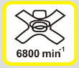Cutting attachment speed

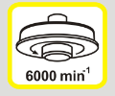 Cutting attachment speed

 Guarantee sound power level

 Be careful of the cutting attachment!

 Do not use in rain and in damp environment

1. **YOUR PRODUCT**
2. **Description**

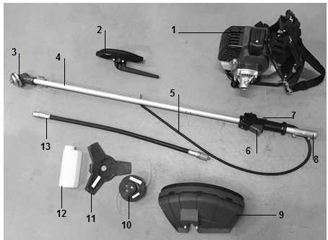

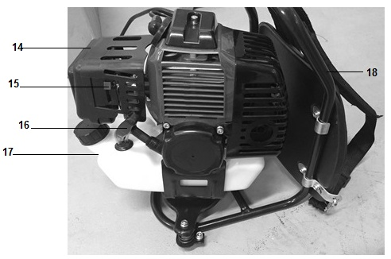

1. Unit
2. Handle
3. Cutting attachment installation
4. Tube
5. Command cord
6. Accelerator throttle
7. ON/OFF switch
8. Tube connector
9. Carter of protection
10. Grass trimmer attachment
11. Brushcutter attachment
12. Bottle for fuel mixing
13. Flexible tube
14. Air filter
15. Choke lever
16. Starter rope
17. Fuel tank
18. Bag pack
19. **Technical data**

|  |  |
| --- | --- |
| **volume (fuel tank)** | 1200 cm³ |
| **cutting attachments (type, diameter for blades), in mm;** | Brushcutter: 420/480 mm, 3 teethes |
| Grass trimmer: Ø2.5 mm nylon cutting wire |
| **engine displacement, in cm3;** | 42.7 cm³ |
| **maximum engine power, in accordance with ISO 8893, in kW;** | 1,35 kW |
| **Maximal speed** | 9000min-¹ |
| **maximum rotational speed of accessories** | 10000min-¹ |
| **Clutch engagement speed** | 4600 min-¹ |
| **Idling speed** | 3100±400 min-¹ |
| **Dry/net weight** | 8,3 kg /15 kg |
| **engine idling speed range** | 3100±400 |
| **Sound power level** | Lwa=107,68dB(A)  KwA=3 dB(A) |
| **Sound pressure level** | LpA:96.25dB(A)  KpA=3,0 dB(A) |
| **Vibration value** | Left handle : 6.582 m/s²  Right handle: 5.405 m/s²  K=1,5m/s2 |
| **Guarantee sound power level** | 114dB(A) |
| **Model of the engine** | RY1E40F-5 |

1. **ASSEMBLY**

**Assembling the flexible tube with the engine and the pipe support**

Insert one end of the flexible tube into the clutch housing on the engine until it locks in place.

Insert the other end of the flexible tube into the brush cutter line until it locks into place.  
The ends of the flexible shaft are interchangeable. Make sure that the end of the flexible shaft is properly seated in the drive shaft seal.

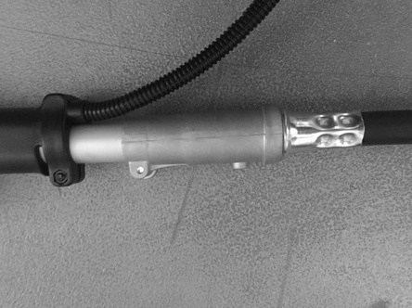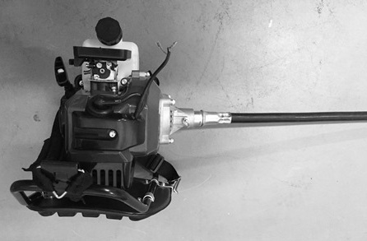

**CAUTION: If the flexible tube is not inserted properly, the square end of the hose may not fit snugly in the drive shaft seal. Do not use force to avoid damage to the flexible shaft. Repeat the same procedure until the flexible shaft and hose are adjusted.**

**Connecting the command cord**

* Connect the command cords to the two engine leads by inserting them into each other.

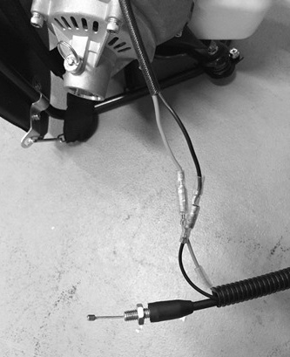

**Mounting the throttle cable**

* Remove the air filter cover.
* Place the throttle cable in the adjusting bolt. Be careful that the round hole of the rotating joint faces the end of the inner wire.
* Leave the rotating seal and make sure that the inside wire is properly seated in the hole.
* Reinstall the cover of the air filter.

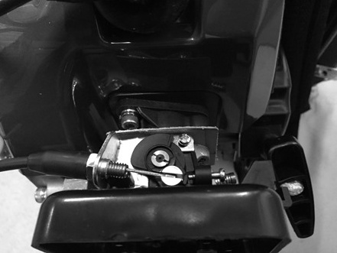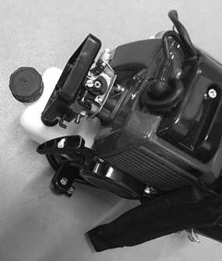

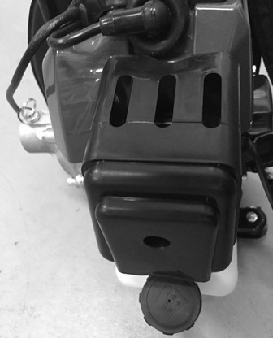

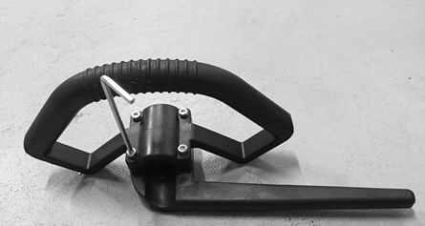**Handle**

* Unscrew with a spanner the handle and the barrier.

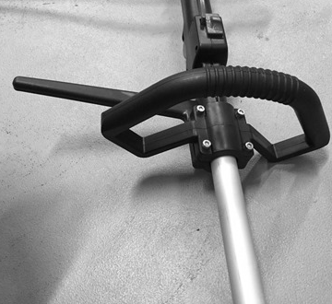

* Install the handle and barrier to the aluminum tube. Fasten the 4 internal hexagonal screws with spanner.

**Carter of protection**

* Remove the screws which are on the carter of protection.
* Install the tube on the carter of protection. Make sure that you have installed it in the correct position.
* Screw the carter on the tube with the two screws.

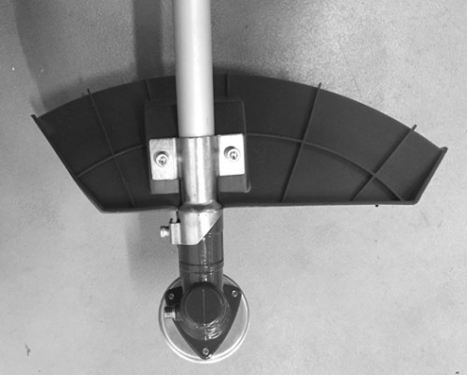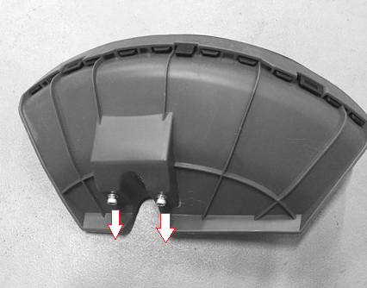

**Installation of the nylon cutting head (for grass trimmer operation)**

* Insert a metal locking tool into the hole on the side of the drive gear and on the tool drive.
* Remove cover bell and the holding nut from the shaft.
* Install and screw the nylon cutting head. Make that it is well installed.
* Remove then the metal locking tool.

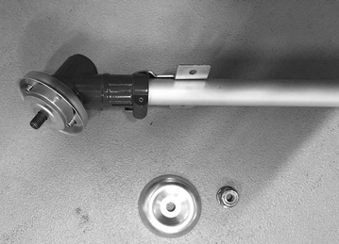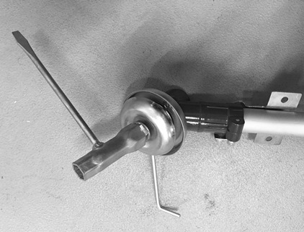

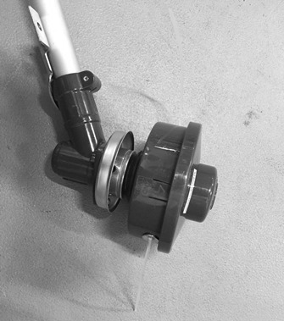

**Installation of metal blade (for brush cutter operation)**

* Insert a metal locking tool into the hole on the side of the drive gear and on the tool drive
* Remove cover bell and the holding nut from the shaft.
* Install, in the following order, on the shaft: the blade, the cover bell and then the holding nut.
* Remove the metal locking tool.

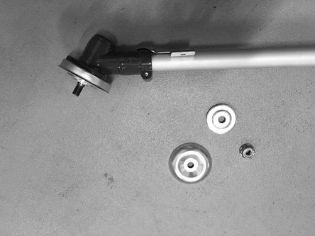

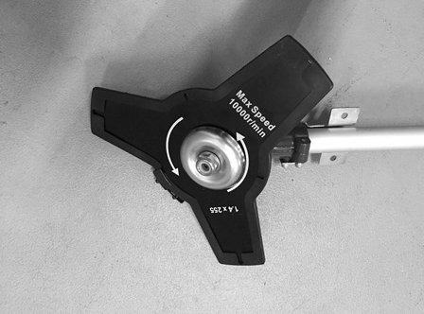

**NOTE**

**After installation, always check if the installation is correct. If blade is not well installed, it will vibrate excessively and can cause injury. When operation, if there is abnormal vibration, immediately stop the tool and check the installation.**

1. **FUEL**

* **Warning: Gasoline is highly flammable. Keep the fuel in specially designed cans.**
* **Only fill the tank outside and do not smoke during the operation. Avoid sparks or open flames near the fuel.**
* **Fill the tank before starting the engine. Never remove the fuel tank cap, add fuel while the engine is still running, or while the engine is still warm.**
* **Avoid overfilling the tank: When excess fuel has escaped, do not attempt to start the engine, but move the machine away and avoid any sources of ignition in the vicinity until the fuel vapors have dissipated.**
* **Fully tighten all fuel filler caps and cans.**
* **Fill the tank on the floor.**
* **The engine must be started at a distance of at least 3 meters from where the fuel tank has been filled.**
* **Switch off the engine before adding fuel. Shake the mixture thoroughly before filling the tank.**
* **Store gasoline in tanks specially designed for this purpose.**
* **Fill the fuel tank of your appliance outdoors and avoid smoking during work.**
* **Fill the tank before starting the engine. Never open the fuel tank cap or fill fuel tank while the engine is running or the engine is still hot.**
* **Avoid spilling gasoline: When gasoline is spilled, do not start the machine and move it away from where the gasoline has spilled to avoid possible sources of fire.**
* **Screw all caps and tank cover carefully.**

This type of tool is designed to be used with unleaded gasoline. Using unleaded gasoline prevents unnecessary pollution in the interests of your health and the protection of the environment. Using gasoline or oil of lesser quality can damage seal rings, ducts or fuel tank.

Exhaust emissions are regulated by the basic technical characteristics of the engine and its components (carburation, adjustment of spark plugs, control of exhaust opening and closing times) in the absence of accessories or a catalyst during combustion.

**Mix**

* Use the supplied bottle to mix.
* Fuel ratio (petrol: 2 stroke engine oil) 40: 1
* Put the oil and then the fuel. Mix thoroughly for at least one minute.

**Filling the tank**

* Unscrew the tank cap.
* Fill the tank to 80% of its capacity.
* Screw the fuel cap back on. Clean the fuel tank cap and the area around after filling the fuel tank. Eliminate overfill of fuel mixture by rubbing.

1. **OPERATION**

**Cold starting**

* Put the tool on a plane surface.
* Push the ON/OFF switch on the ON position.

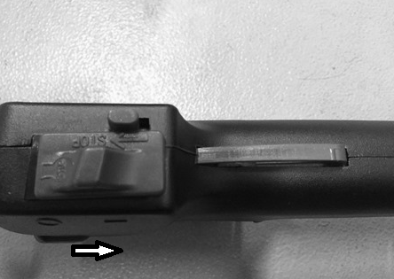

* Close the choke lever.

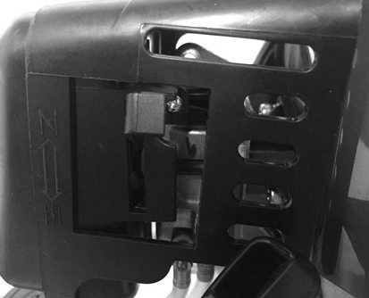

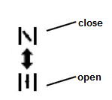

* Push the priming bulb 7 to 10 times.

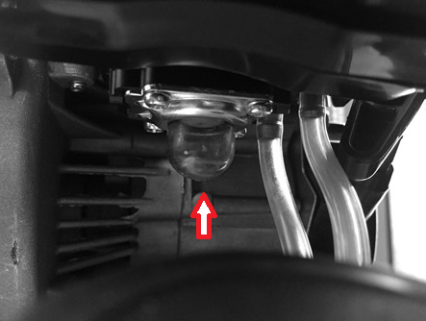

* Pull the starter rope until the engine starts.

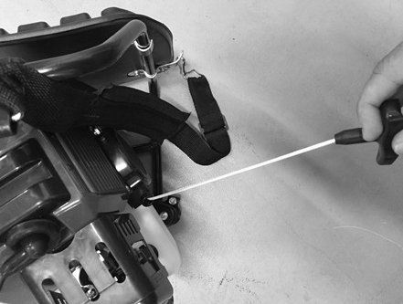

* Press and hold the safety switch and then accelerator throttle to start the operation

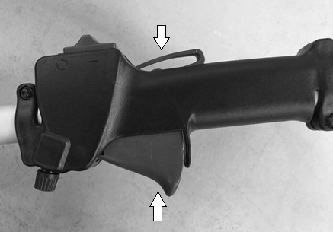

**Hot starting**

* Partial the choke lever or open the choke lever

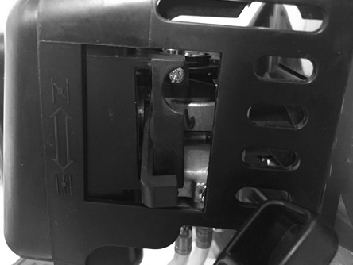

* Pull the starter rope.



* Press and hold the safety switch and then accelerator throttle to start the operation



**Stopping**

* Release the accelerator throttle.
* Push the ON/OFF switch on the OFF position.

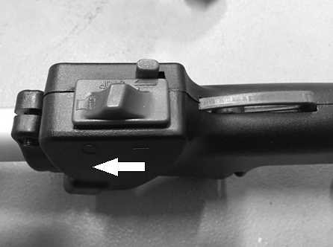

* Let the tool completely stop

1. **Grass trimmer operation**

* **Trimming**

Tilt the head slowly to direct debris away from you. If cutting up to a barrier such as fence, wall or tree, approach from an angle where any debris ricocheting off the barrier will fly away from you, Move the line head slowly until the grass is cut right up the barrier, but do not jam (overfeed) the line into the barrier. If trimming up to a wire mesh or chain linked fence be careful to feed only up to wire. If you go too far the line will snap off around the wire. Trimming can be done to cut through weed stems one at a time. Place the trimmer line head near the bottom of the weed-never high up which could cause the weed to chatter and catch the line. Rather than cut the weed right through, just use the very end of the line to wear through the stem slowly.

* **Scalping and edging**

Both of these are done with the line head tilted at a steep angle Scalping is removing top growth leaving the earth bear.

Edging is trimming the grass back where it has spread over a sidewalk or drive way. During both edging and scalping, hold the unit a steep angle and in a position where the debris, and any dislodging dirt and stones, will not come back towards you even if it ricochets off the hard surface. Although the picture shows how to edge and scalp every operator must find for himself the angles which suits his body size and cutting situation.

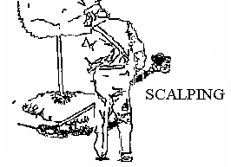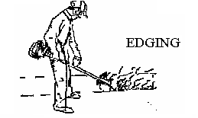

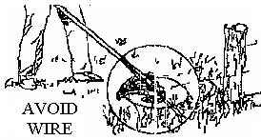

1. **Brushcutter operation**

* Do not the brushcutter for cutting trees
* Do not cut with dull, cracked or damaged meal blade.
* Before cutting growth, inspect for obstructions such as boulders, metal stakes or strands of wire from broken fences. If an obstruction cannot be removed, mark its location so that you can avoid it with the blade. Rocks and metal will dull or damage a blade. Wire can catch on the blade head and flap around or be thrown into the air.
* Use the shoulder harness at all times adjust both harness and harness clamp on the unit so that the unit hangs a few inches above ground level .The cutting head and the debris shield should be level in all directions. Harness the unit on the right side of your body.
* Cut only with the side of the blade that the debris is moving away from you.
* If kickback occurs, the blade may be dull, or the material so thick and hard that you should use other tool instead of this machine.
* Do not force the blade to cut. Do not change the angle of cut after into the wood. Avoid using any pressure or leverage which could cause the blade to bind or crack.

**Scything weeds**

This is cutting by swinging the blade in a level arc. It can quickly clear areas of field grass and weeds. Scything should not be used to cut large, tough weeds or woody growths.

Scything can be done in both directions, or just in one way which results in the debris being thrown away from you.

That is using the side of the blade that it is rotating away from you. Tilt down the blade slightly on this same side. You will be hit by some debris if you scythe in both directions.

1. **STORAGE**
2. **Air filter**

* Accumulated dust in the air filter will reduce engine efficiency. Increase fuel consumption and allow abrasive particles to pass into the engine. Remove the air filter as often as necessary to maintain in a clean condition. Light surface dust can readily be removed by tapping the filter. Heavy deposits should be washed out in suitable solvent.
* Remove filter cover by loosening air filter cover knob.

1. **Adjusting the carburettor**

Do not adjust carburettor unless necessary. If you have trouble with the carburetor, see your dealer. Improper adjustment may cause engine damage and void warranty.

1. **Fuel filter**

When the inside of the fuel tank is dirty, it can be cleaned by rinsing the tank out with gasoline.

1. **Spark plug**

Do not attempt to remove the plug from a hot engine in order to avoid possible damage to the threads.

* Clean or replace the spark plug in case of ozone contamination.
* Replace the spark plug if the end of the center electrode is worn.

1. **Handling and transport**

* The engine should be turned off when the unit is moved between work areas.
* After the engine has stopped, the muffler is still hot. Never touch hot parts such as the muffler.
* Confirm that the fuel is not leaked from tank.
* Transport the tool in a way to prevent loss of fuel, injuries and damage.
* Dismantle the cutting head and the blade before transport and storage. Put on the blade its protection.

1. **Storage**

* Inspect, clean and have the appliance repaired if necessary
* Empty the tank.
* Switch on the appliance to consume all remaining fuel.
* Remove the spark plug and pour a teaspoon of clean engine oil into the cylinder cavity of the spark plug, replace the spark plug
* Store cutting elements so that they cannot be touched (wrap them, for example.)
* Store in a clean, dry, dust-free area.

**Warranty**

We guarantee this product for 2 full years.

The warranty period for this item starts on the day of purchase. You can prove the date of purchase by sending us the original receipt.

We insure over the entire warranty period:

• Free repair of possible malfunctions.

• Free replacement of damaged parts.

• Including the free service of our specialized personnel (i.e. free assembly by our technicians)

Provided that the damage is not due to improper use of the device.

To help you with your product, we invite you to use this link or call us on +33 (0)9 70 75 30 30:

https://services.swap-europe.com/contact

You must create a "ticket" via their platform:

• Register or create your account

• Indicate the reference of the tool

• Choose the subject of your request

• Explain your problem

• Attach these files: Invoice or receipt, identification plate photo (serial number), photo of the part you need (eg broken transformer plug pins)



1. **CE DECLARATION**

**BUILDER SAS**

ZI, 32, rue Aristide Bergès – 31270 Cugnaux - France

Tel: +33 (0)5.34.502.502 Fax: +33 (0)5.34.502.503

Declares that the machine:

**BRUSH CUTTER & GRASS TRIMMER**

**HDBTD45-A1**

**Serial No: 20181236675-20181236924**

The people name holding the technical file：Mr. Olivier Patriarca

Have been designed in compliance with the following standards:

EN ISO 11806-2:2011

EN ISO 11680-2:2011

EN ISO 10517:2009/A1:2013

And in accordance with the following directives:

Directive Machine 2006/42/EC

Directive EMC 2014/30/EU

Noise Directive 2000/14/EC Annex V & Directive 2005/88/EC

Emission directive 97/68/EC &2010/26/EU

|  |  |
| --- | --- |
| **Sound power level** | Lwa=107,68dB(A)  KwA=3 dB(A) |
| **Guarantee sound power level** | 114dB(A) |

Philippe MARIE / PDG

**

Cugnaux, 02/08/2018

